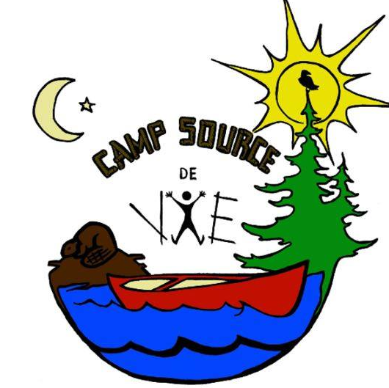

P.O. Box 2428, Hearst, On, P0L1N0
Phone: 705-373-0189
campsourcedevie@gmail.com
campsourcedevie.com

Items to bring
The following items are mandatory:
o reusable water bottle
o pajamas
o 3 warm vests
o 2 towels
o 2 washcloths
o 5 t-shirts
o Toothbrush and toothpaste
o Coat
o 5 underwear
o 3 short pants
o Swimsuit
o 5 pairs of stockings
o Sneakers
o 2 jeans or jogging suits
o Sunscreen and insecticide
o Sleeping bag
o Pillow
o Biodegradable soap
o Biodegradable shampoo
o Flashlight
o Waterproof set and boots
* NO electronic object (ipod, iphone, ipad, mp3 ...)
* NO weapon or food

